Secure RESTful Communication

Kudzo Zounou, Dhroov Pandey
Department of Computer Science and Engineering, University of North Texas
CSCE 4050/5050: Applications of Cryptography
Prof. Kirill Morozov
April 3, 2026

Abstract

Introduction
This project aims to implement a secure communication between a server and a client. The problem we are trying to solve is the confidentiality and integrity of the data that the client receives from the server. To achieve this, we employed asymmetric encryption to provide data confidentiality and a Message Authentication Code (MAC) for data integrity. The programming of choice for this project is Python with Flask as the library of choice for implementing the REST server.

Related Works

Approach
For the implementation of the project, we utilized the following:
- Python programming language
- Ubuntu 20.04 VM for running a
- Wireshark for capturing packets on the localhost.

Task 1
At this stage, we set up a “weather” endpoint in the server’s code that returns some static JSON data, the client fetches the data via a GET request, and Wireshark capturing the communication between the server and client. Image 1 below shows the server running on the localhost and on port 5050.

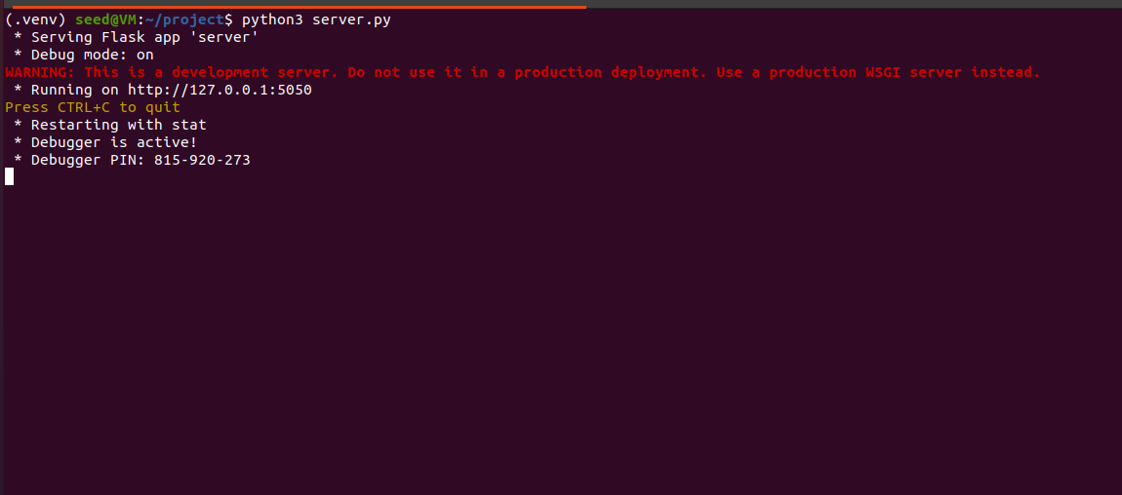
Image 1: Screenshot showing the server running

Task 2
At this stage, we implemented data encryption using a pre-shared key and data integrity by signing the data using a HMAC key, both keys being hardcoded into the server and client codes.

Task 3
At this stage, we generate a private/public key pair using RSA for the confidentiality and integrity of the data.
- The client first gets the server’s public key, generates a random session key, encrypts the session key with the server’s public key and sends it to the server via a POST request.
- The server receives the client’s encrypted session key, decrypts it with the private key and establishes a session using the client’s decrypted session key.
- The server then uses the client’s session key to create two other keys: one to encrypt the data and one to sign it.
- The client then fetches the encrypted data from the server and decrypts it using its session key as shown in Image 2.

Task 4
At this stage,

Results
When the client code is executed, it displays the data in plaintext. For each step of this project, the data is sent unencrypted, then in the following stages we employed both symmetric and asymmetric encryption to provide confidentiality to the data. Image 2 shows the data that the client received in each stage which is the same.

Task 1
- Image 2 shows the client receiving the weather data.
- Image 3 shows Wireshark intercepting the data.
- Image 4 shows the HTTP stream and reveals that the data is sent in plaintext.
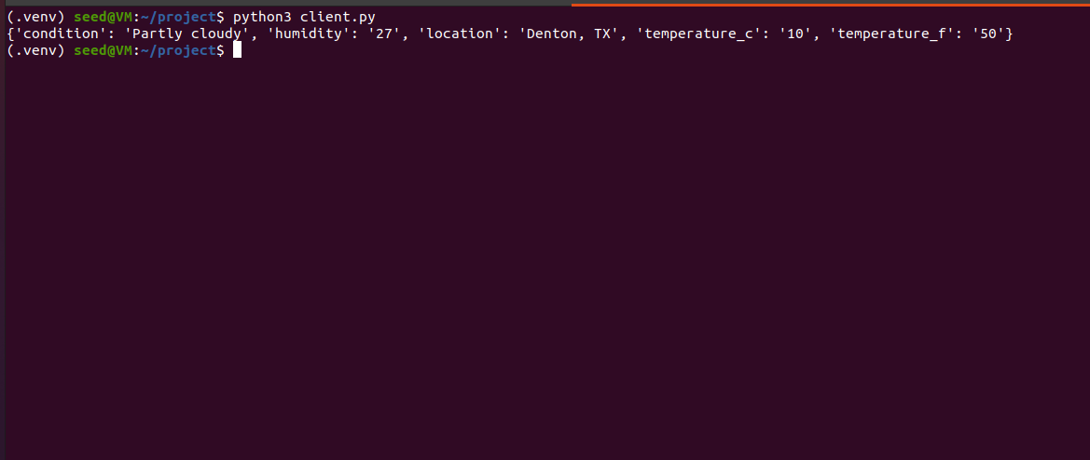
Image 2: Screenshot showing the data the client got from the server in plaintext
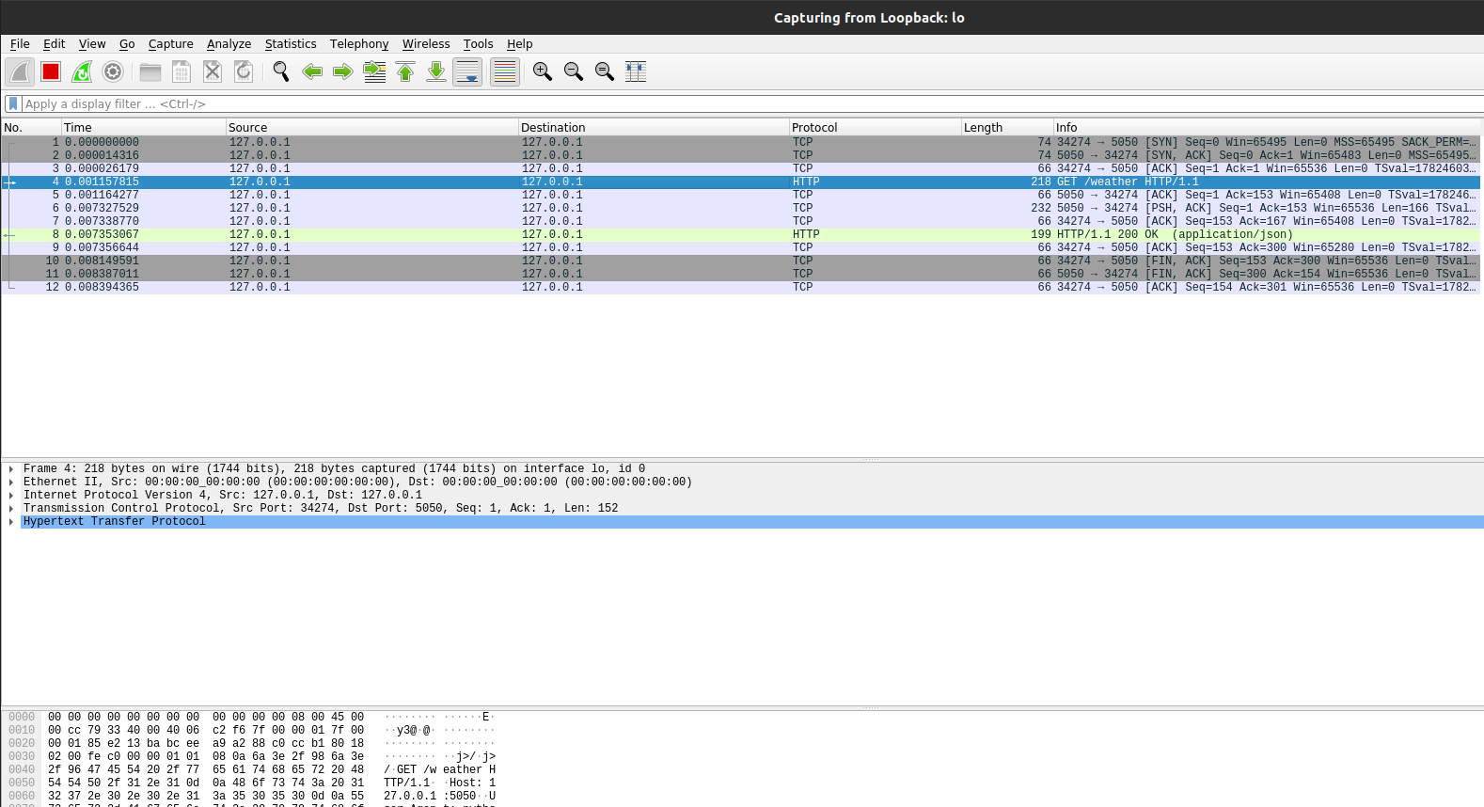
Image 3: Screenshot showing the captured packets in Wireshark’s interface
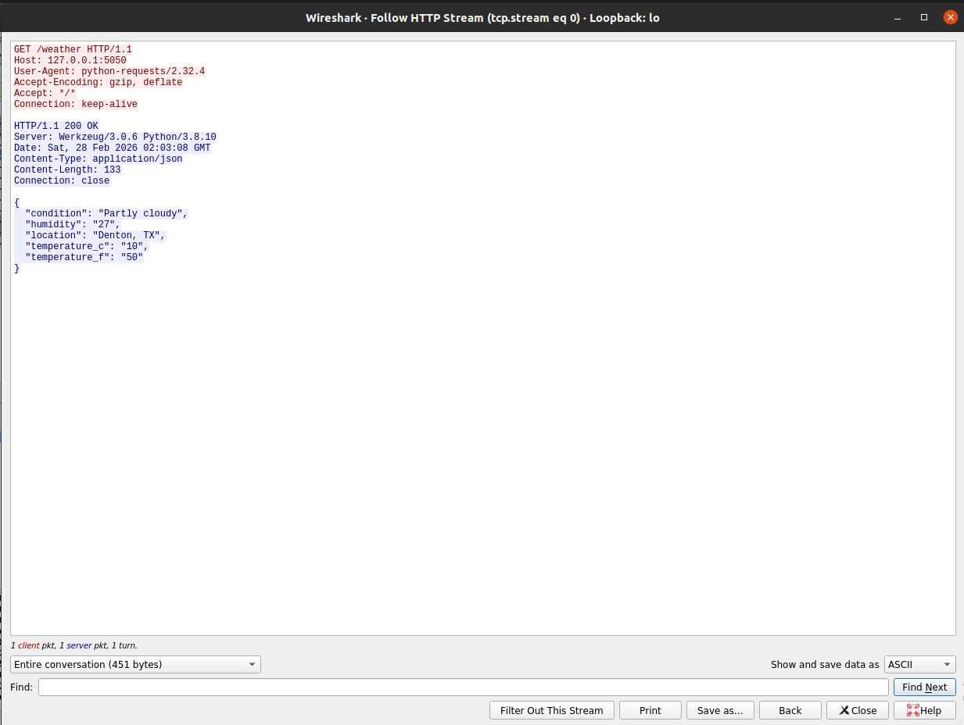
Image 4: Screenshot showing the plaintext data in the HTTP stream

Task 2
- The client code displays the plaintext data as shown in Image 2.
- Image 5 shows in the HTTP stream that the intercepted data is encrypted.
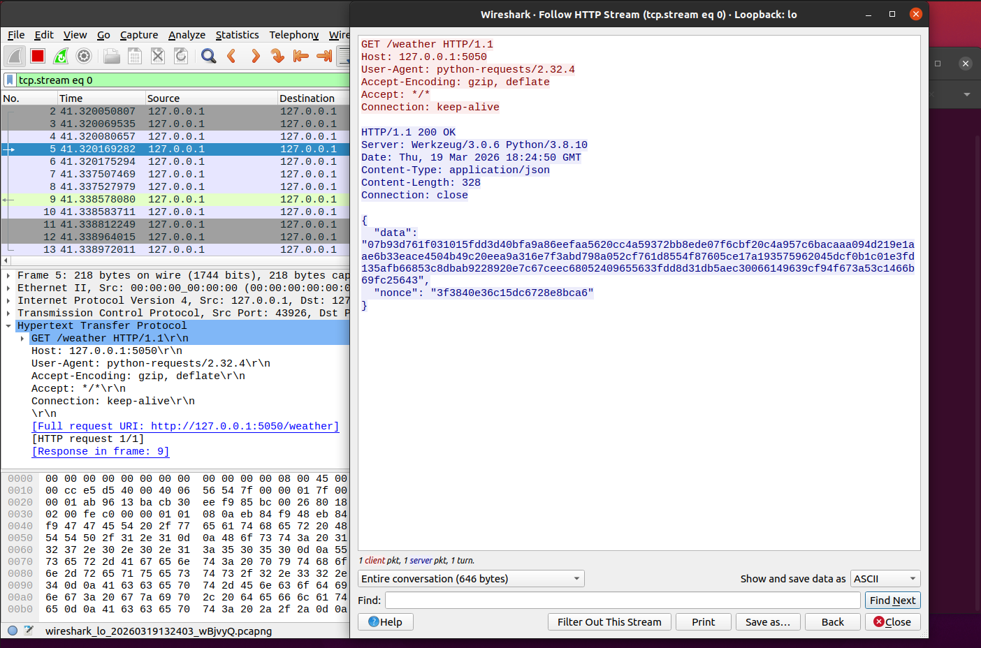
Image 5: Screenshot showing the encrypted data in the HTTP stream

Task 3
These are the results tthat we observed using Wireshark’s HTTP stream.
- Image 6 shows the server’s public key that the client got from the GET request.
- Image 7 shows the client’s encrypted session key that it sent to the server via the POST request and a “OK” message confirming the successful delivery.
- Image 8 shows the encrypted data alongside the signature.
- The client code displays the plaintext data as shown in Image 2.

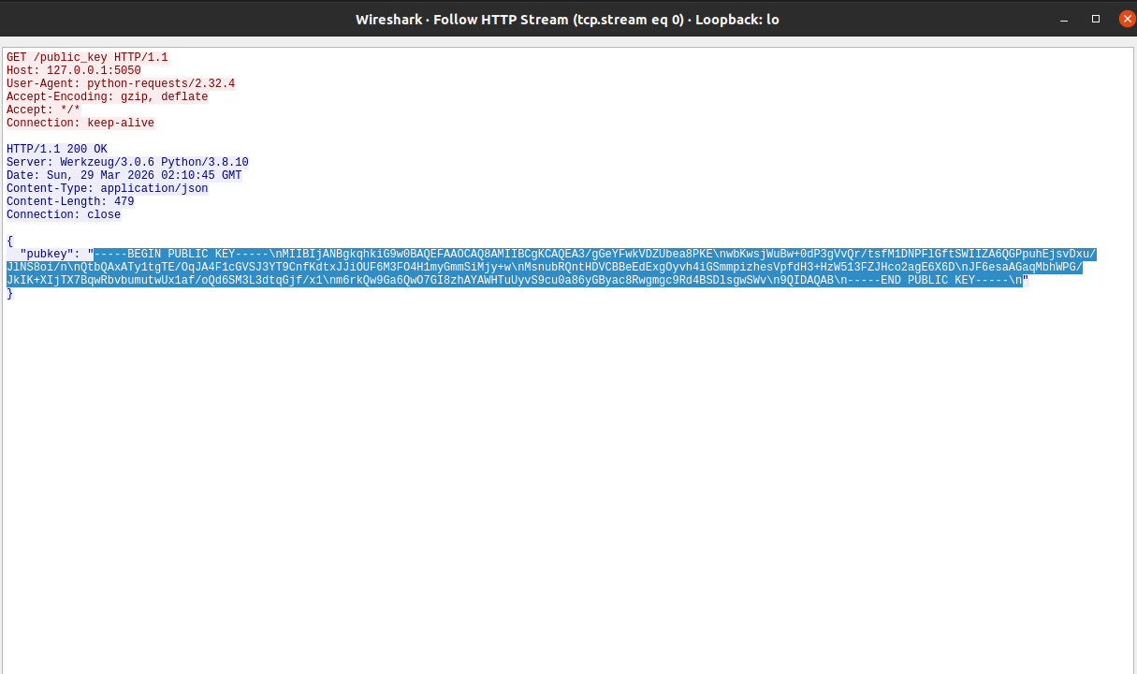
Image 6: Screenshot showing the server’s public key

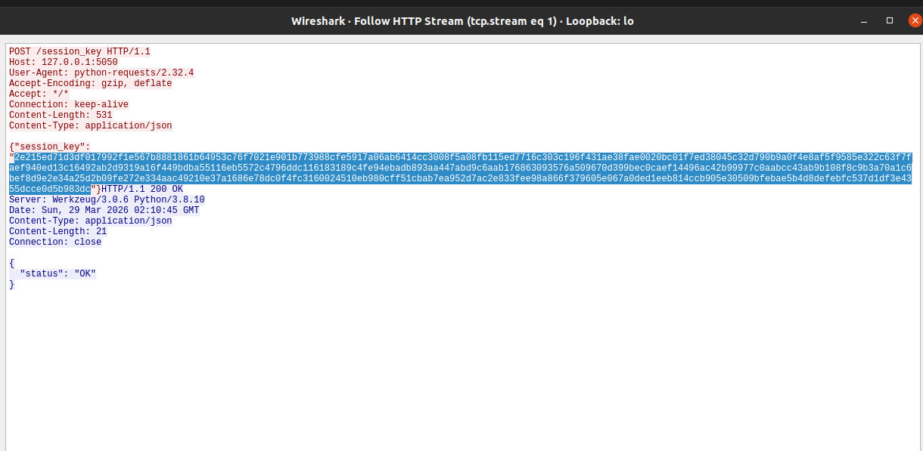
Image 7: Screenshot showing the client’s encrypted session key
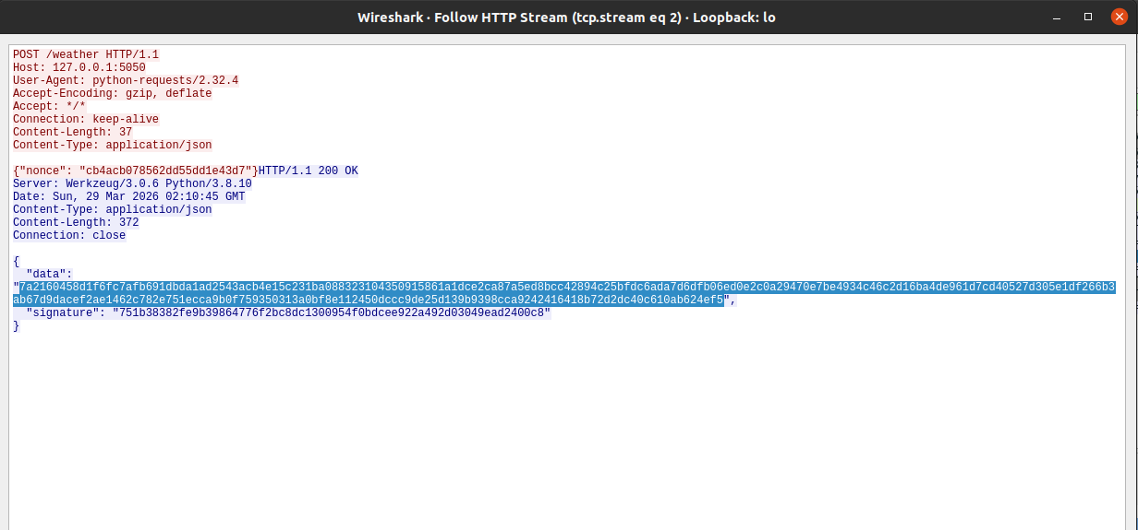
Image 8: Screenshot showing the encrypted data the client fetched from the server

Task 4
At this stage,
References
Pyca/cryptography. RSA. https://cryptography.io/en/latest/hazmat/primitives/asymmetric/rsa/#module-cryptography.hazmat.primitives.asymmetric.rsa

Reference

Reference

